Title (Times New Roman, Bold, size:14)
FirstAuthorName Surnameª, SecondAuthorName Surname^{b}, etc. (Times New Roman, Normal, size 14)
^{a,b,etc.}Affiliation(s) (Times New Roman, Italic, size 12)

The abstract must be written in English (U.K or U.S.A but not a mixture of them) and should not exceed one page. The text of the abstract must be written in Times New Roman, Normal, size 12. The space between lines must be set at 1.5. The Title must be written in Times New Roman, Bold, size 14. First name and surname of the participant must be written entirely while only the first letter of the second, third (etc) names must be reported. Write the name and surname in Times New Roman, Normal, size 14. Regarding the affiliation(s), please write it in Times New Roman, Italic, size 12. If necessary you can add also one figure or one table at the end of the abstract. The caption must be reported just below the figure/table in Times New Roman, Normal, size 12 (as in the example below).
References can be also reported at the end of the abstract (as in the examples) and indicated as numbers ([1,2, etc.]) beside the corresponding line in the text. They must be written in Times New Roman, Normal, Size:12.
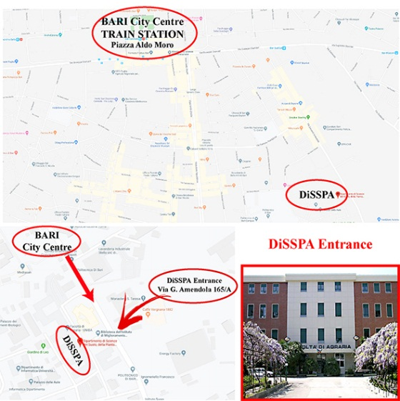
Figure 1. How to reach DiSSPA (Times New Roman, Italic, size 12)

REFERENCES:
[1] Van der Geer, J., Hanraads, J.A.J., Lupton, R.A., 2010. The art of writing a scientific article. J. Sci. Commun. 163, 51-59. (for papers in journals)
[2] Bergaya, F., Theng, B.K.G., Lagaly, G. (Eds.), 2006. Handbook of Clay Science. Elsevier, Developments of Clay Science, Volume 1, Amsterdam. (for books)

